Please complete the following. You may email responses to sales@pantingportraits.com
- Dog’s name:

2. Please write a description of the dog.
Include personality, any special thing that pops out about your pup: favorite toys, favorite activity, etc. Note any special marking or features, such as "my dogs left ear is always flipped up!”

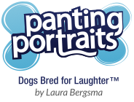
3. If you have a vision or idea for your drawing please explain.
If not, I will provide ideas.

4. Background color preferences?

5. Please provide several good photos of your dog via email.
Send a few taken at the dogs level. Provide other photos that show special markings and coloring of fur and color of eyes. You can email high quality jpeg files to: sales@pantingportraits.com,
Or provide links to instagram posts, facebook posts, or online galleries that have photos.

